**Self-administration of Vitamin B12 Injections**

NOTE: This instruction leaflet is only meant for those patients of Stokewood Surgery who have discussed their vitamin B12 treatment plan with one of the healthcare professionals at the surgery and agreed to self-administration of B12 injections.

**Equipment** required for self-administration of B12 injections:

1. 3ml syringe,
2. Green or Blue needle
3. Red filter needle
4. Vitamin B12 Ampoule
5. 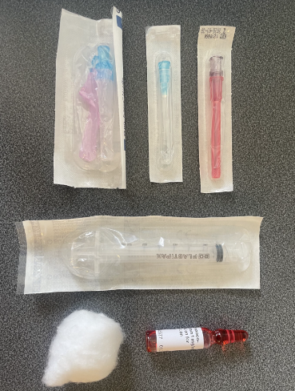Cotton wool

1

1. Sharps bin

5

4

3

2

If you do not have the above equipment, please contact the reception team to organise the collection of the required equipment before starting.

**Procedure:**

1. Check the expiry dates of all equipment and vitamin B12 ampoule
2. Ensure you have a clean and dry area to prepare your equipment
3. Ensure the injection site is visibly clean
4. Wash hands thoroughly with soap and warm water
5. Open packets of the red needle, green/blue needle and syringe
6. Attach red filter needle to the syringe
7. Ensure that there is no B12 solution in the top half of the ampoule by gently tapping/ rubbing it on your preparation surface.
8. Using the syringe packaging (to prevent cutting yourself when the ampoule breaks), hold the top of the ampoule with the dot pointing towards you and then push the top of the ampoule away from the dot to break the ampoule open at its centre.
9. Discard the empty top of the glass ampoule into the sharps bin
10. Using your red filter needle and syringe, draw the B12 solution into the syringe
11. Discard the red needle and the empty bottom of the glass ampoule into the sharps bin
12. Push a blue/ green needle onto the nozzle of the syringe of medication until you hear a click
13. Expel any excess air by gently pushing the plunger up
14. Remove the cover of needle to expose the needle tip
15. Insert the needle at a 90degree angle into the middle ⅓ of the outer-front of the thigh.

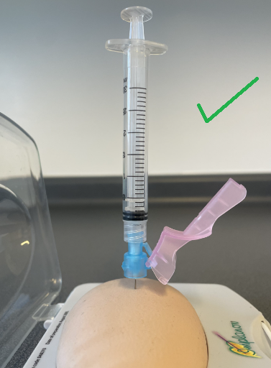

(Examples of correct 90degree angle) (Injection Site)

1. Gently push down the plunger so that the medication is administered over approximately 10 seconds.
2. Remove the needle and press on the injection site with a cotton wool ball for approximately 30 seconds (or until the bleeding stops)
3. Close the safety cap of the syringe by pressing it against a hard surface
4. Put the used needle and syringe into the sharps bin
5. The rest of the empty packaging can be disposed of in a normal rubbish bin

**Any questions, please contact the surgery to discuss with one of the nursing team.**

**Personal Reminder / Record Log:**

|  |  |
| --- | --- |
| Date Administered: | Next Due: |
|  |  |
|  |  |
|  |  |