Stokewood Friends and Family Feedback September

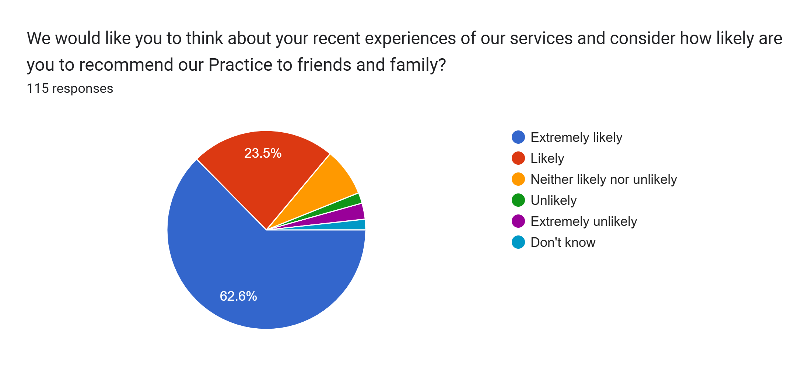

|  |  |  |  |  |  |
| --- | --- | --- | --- | --- | --- |
| Extremely likely | Likely | Neither likely nor unlikely | Unlikely | Extremely unlikely | Don’t know |
| 72 | 27 | 9 | 2 | 3 | 2 |

|  |  |
| --- | --- |
| Neither likely nor unlikely | Nurse practitioner was excellent. Ridiculous that I couldn't rebook an appointment at reception. |
| Neither likely nor unlikely | My son waited 2.5 months for an appointment about sleep/potantial adhd. For them to tell us that he needed to see a specialised doctor. This was super unhelpful! |
| Extremely likely | Very efficient in all departments. A great surgery. |
| Extremely likely | Considering how busy Stokewood is I was given a face to face appointment the same day. Excellent service. A big thank you from myself. |
| Extremely likely | Always friendly and professional |
| Extremely likely | The doctor I saw is a asset to your gp surgery I’ve had bad experiences from your other doctors at your practices but doctors garland was by far the best doctor I’ve seen he was kind understanding and very professional as well as putting my mind at ease and he was a grateful laugh as well I hope this feed back gets to him |
| Extremely likely | Clear diagnosis |
| Extremely likely | Always receive polite and respectful responses from the reception staff. The healthcare given at all levels is thorough and I feel I am listened to and my needs are taken on board & dealt with appropriately and efficiently. Congratulations on a brilliant service. |
| Likely | I’d sustained a cat bite recently and following the econsult pathway, was advised to speak to someone. I phoned the surgery who informed me I would receive a call, this happened with in a short time and I was duly given an appointment that same afternoon with an APN. All went smoothly, had a tetanus booster and was prescribed a short course of antibiotics. Frustrating thing was going all the way through econsult only to be told to call the surgery, this has happened to me before as well. |
| Likely | Managed to see a GP |
| Extremely likely | Always pleasant and thorough |
| Extremely likely | Appointment was on time. Relaxed and good information |
| Extremely likely | Very speedy response |
| Extremely likely | An excellent example of care and attention. |
| Extremely likely | After submitting the e-consult I was contacted straight away and offered an appointment within the hour for my son. We were seen 5 minutes early as well by the doctor and prescribed medication. Great experience. |
| Likely | No comment |
| Extremely likely | My appointment was with Dr Tromans for my six monthly pessary ring change. She was very gentle and caring. I feel like she always has time for her patients and answers any queries you have and is very helpful. |
| Extremely likely | Dr always very thorough, caring, communicates well, reassuring |
| Likely | - |
| Extremely likely | Excellent help and response. |
| Extremely likely | The doctor I saw was friendly and understanding and put me at ease |
| Extremely likely | Very clear information given and followed up with a leaflet in case I hadn’t heard all I was being told |
| Extremely likely | Speedy appointment this time with paramedic. Friendly and professional session |
| Likely | Appointment easy, parking not so easy, seeing nurse a little delayed, getting prescription a failure cos it's not in stock. |
| Extremely likely | Our daughter was booked an appointment on the day despite being short staffed. The doctor we saw was patient, kind and sorted her out with medication straight away. Thank you |
| Extremely likely | Very thoughtful care and support |
| Unlikely | I find it frustrating I can never see a GP nowadays. I request an appointment because I feel like either my children or I need the advice of a GP yet we never manage to see one. I think this is unfair on the patient and the member of staff who although is trying to help, ultimately, they're not qualified to the level of a GP. I've said this a number of times now and yet my feedback is never acknowledged, I'm never asked to expand further and we still don't get to see a GP. Surely on a human level, whoever reads this can understand my frustration!? |
| Extremely unlikely | Receptionists are so so rude |
| Extremely likely | My baby was seen the seen the same day as e-consult submitted. Very friendly doctor and was great with my baby |
| Extremely likely | Fab service for stoke wood surgery |
| Likely | Unable to book an appointment on the e-form. So had to call the practice, for them to fill in the same form... After all this palaver, got an appointment later the same day. |
| Unlikely | Access and help for my medical problems are poor. |
| Extremely likely | Very happy with the way I was treated |
| Neither likely nor unlikely | Doctor did not appear interested in what I was saying. Offered a prescription but did not give it to me |
| Extremely likely | Extremely helpful and understanding advice |
| Likely | Although I turned up 6 minutes late (due slow traffic caused by bad weather)I was seen without a fuss. The Doctor was both professional and efficient |
| Extremely likely | Dr Koshy did a very thorough check of my daughter’s illness, which I was very grateful for her patience and referring me to the CHAT team who helped me further. |
| Likely | Understanding doctor |
| Likely | Na |
| Extremely likely | Treated like an equal and a grown up. I enjoyed it |
| Extremely likely | Super convenient and fast way to reach out to the practice and extremely fast and efficient call back and appointment. Thank you |
| Extremely unlikely | Had to wait 8 weeks for an appointment & I had to ring & chase it. Dr I saw was lovely but this is no service. |
| Extremely likely | Thoroughly good appointment with examination & advice given. Thank you |
| Extremely likely | Friendly /caring/ welcoming |
| Extremely likely | Very professional and friendly |
| Likely | Dr Diggens was very thorough in my examination and I believe she is a very good doctor |
| Extremely likely | Dr Straughan is brilliant he listens to my concerns and I feel gives me the best care.  Just wish I could get quicker appointments when needed. |
| Extremely likely | Prompt and helpful |
| Extremely likely | Always get a quick response |
| Likely | Good appointment and swift. Only downside was the prescription. Prescribed a drug that was discontinued and had to come back and get a generic authorised. Seems a quick win to save everyone time and hassle |
| Extremely likely | Used the E consult system which indicated that I should ring the surgery, made phone call and got appointment straight away very good service |
| Likely | Positive appointment |
| Neither likely nor unlikely | A doctors surgery used to be a haven you would go to to get help when you are sick. Now it has become a stressful experience of being made to feel that you are a nuisance and asking the impossible to get that help. The love and nurturing has long gone, the receptionists are under such pressure and work load that they can’t cope and sometimes come across in a manner which is not kind and we are made to feel guilty for TRYING to make an appointment. Once we manage to get an appointment we have to wait so long for it, either our symptoms are so bad or the opposite and serious conditions are overlooked ie. cancer or other life threatening illnesses.  I think the whole system in England is broken and unfortunately that applies to Stokewood as well. |
| Extremely likely | It was a pleasure to see Dr Jacobs, very helpful and caring. |
| Likely | Seen that day. Friendly. Follow up organised. Thank you. |
| Extremely likely | Very happy with the service you provide |
| Extremely likely | Dr Straugham and team were very professional and referred me to SGH with head injury. |
| Likely | Reception very friendly calling in first in on hold took time to answer telephone nurse was extremely good. |
| Extremely likely | Prompt service with a smile |
| Extremely likely | Really excellent service. E-consult submitted at 8, appointment at 12 the same day |
| Extremely likely | Very efficient quick service |
| Extremely likely | Mark is an outstanding member of the team. I have total confidence in his judgement and abilities. |
| Extremely likely | A quick service |
| Extremely likely | Dr Tromans is a lovely GP who does her best to listen and make the patient feel like their concerns are being taken seriously. I also saw Marie for an ECG and blood test and she was friendly and professional. |
| Neither likely nor unlikely | I haven’t had the outcome of my visit yet . I am supposed to receive another two appointments. I have not had them yet . |
| Extremely likely | Very pleased |
| Likely | I am more than happy to recommend Stokewood surgery, I have always found the staff to be polite and helpful. |
| Extremely likely | Cannot fault practice. Just wish it was quicker to get calls answered |
| Extremely likely | I had a very quick response to my e-consult and was happy with treatment. Mike was very easy talk to and put me at ease immediately. I would happily see him again. |
| Extremely likely | The whole team (from booking through to the appointment itself) very friendly and efficient - thank you! |
| Likely | . |
| Don't know | Terrible treatment from receptionist trying to book Covid jab no understanding of government guidelines I have myeloma and have had stem cell treatment and reduced immunity and was accused of being rude. I found it all upsetting. Went to pharmacy situation resolved they were wonderful. Made your receptionist very poor and unsympathetic |
| Extremely likely | Never had to wait long when I arrive . Doctor very patient and helpful. Parking can be tricky. |
| Extremely likely | Courteous and friendly reception. Good feedback from Doctor. |
| Extremely likely | Dr Lioyd very professional and knowledgeable and vey polite and very helpful |
| Neither likely nor unlikely | Very pleased with Dr Muthie for her efforts on trying to solve my problem |
| Extremely likely | Very easy to get appointment and sort out prescription that was no longer available thanks |
| Extremely likely | Very quick to see me and very helpful |
| Neither likely nor unlikely | Appointment went well, although follow up not very good. Been sent a link to services that does not work and no contact details to follow up and resolve??? |
| Extremely likely | Always professional and supportive of my needs. Thank you. |
| Extremely likely | Helpful reception team and doctor. |
| Extremely likely | The doctor was very kind, informative and explained the pathway very clearly. |
| Extremely likely | Call surgery due to feeling unwell wasnt able to complete an e consult this was done over the phone. I recieved a call back and was given an appointment. From intial call to collecting my persciption lest than two hours. |
| Likely | My econsult was reviewed, I was seen by a doctor and solution agreed - done! |
| Likely | I was pleased to have the opportunity to ask specific questions about my medical condition and to be provided with reassuring answers. |
| Likely | None |
| Likely | Surgery has got better, doctors good staff helpful, just not enough slots for things like blood tests |
| Likely | Quick triage and was enabled to secure an appointment to see a doctor that morning |
| Extremely likely | The GP was amazing, very understanding, very knowledgeable, she spent time listening to my concerns. |
| Extremely likely | So happy with all the medical support Dr Seymour is currently providing me. |
| Extremely likely | After my appointment with the Asthma nurse, who listened to me and referred me back to the Dr and my then appointment with Dr Lloyd I felt “heard” with regard to this issue I have been trying to sort for 6 years! Hopefully together we might end 6 years of misery |
| Extremely likely | All staff are always very friendly and helpful and not many delays . |
| Extremely likely | Very fast response to my econsult Saw a doctor within an hour thank you |
| Extremely likely | No problems |
| Extremely likely | No oroblems |
| Neither likely nor unlikely | I was surprised and pleased to be offered a same day appointment following my e-consult. I was reassured about my condition and given exercises to help improve it. I understand the doctor’s need to use a face mask, but it was difficult to understand a softly spoken man with an Asian accent when I couldn’t see his lips. Are there no transparent face masks in this day and age? |
| Neither likely nor unlikely | I had to wait 3 weeks for my appointment and all that time was suffering from tonsillitis. I feel that this was far to long to wait. |
| Likely | I saw the PCN at the surgery - she was lovely and very helpful - treated me for a viral infection which has now resolved itself |
| Extremely likely | Always have good service. GP saw me quickly and test done quickly too . All very polite and respectful. You all work very hard in a busy environment. Receptionist dealt with a tricky person very well. |
| Likely | Treatment and medication supplied |
| Extremely likely | Always found the surgery helpful |
| Extremely likely | Appointments have always been timely |
| Extremely likely | Always had a good, pleasant professional and helpful service |
| Likely | . |
| Extremely likely | The doctor took his time to consider the options |
| Likely | All very helpful |
| Extremely likely | I was very impressed with the service I received, it was first class. I highly recommend the doctors that have been treating me,and the reception staff are excellent |
| Don't know | No comments |
| Extremely unlikely | Not very helpful |
| Extremely likely | Same day appointment appreciated |
| Extremely likely | Very happy with the wait time. Very happy with the surgery and staff. |
| Likely | Good service |
| Extremely likely | Very good service |
| Likely | Dr was very nice and listened to me. |
| Extremely likely | Good helpful receptionist team |