Stokewood July Feedback

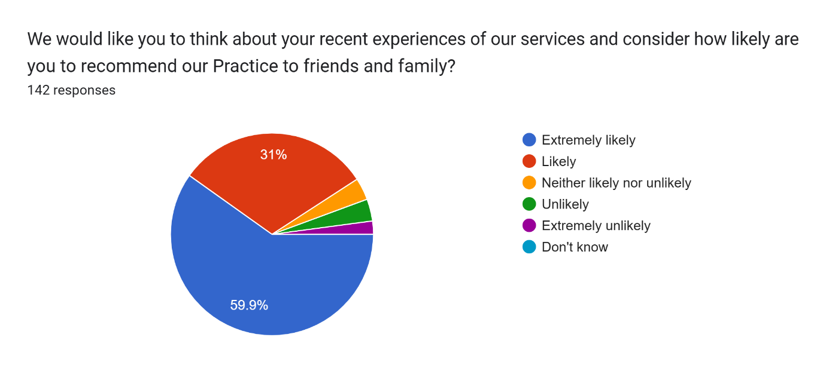

|  |  |  |  |  |  |
| --- | --- | --- | --- | --- | --- |
| Extremely likely | Likely | Neither likely or unlikely | Unlikely | Extremely unlikely | Don’t know |
| 85 | 44 | 5 | 5 | 3 |  |

|  |  |
| --- | --- |
| We would like you to think of your recent experiences about our services and consider how likely are you to recommend our Practice to friends and family? | Your comments |
| Likely | Quick call back. Dr made me feel listened to |
| Extremely likely | Great surgery, very helpful. Staff. |
| Extremely likely | First couple of visits I have had at the surgery since changing. Everyone are thorough, polite and helpful. |
| Unlikely | Always delayed appointments. Doctor I saw last was abrasive and minimising, could have been a phone appointment as he was completely unhelpful |
| Likely | Seen in reasonable time |
| Extremely likely | Brilliant as usual thank you |
| Neither likely nor unlikely | N/A |
| Extremely likely | Always polite and patient |
| Extremely likely | Can’t fault them! |
| Extremely likely | Extremely helpful staff. From the econsult I was seen in a matter of hours and started treatment. Very efficient service. |
| Likely | Friendly and efficient staff |
| Neither likely nor unlikely | None |
| Extremely likely | I love everything about the service rendered |
| Extremely likely | Rapid response to urgent need |
| Extremely likely | Was seen very quickly by the paramedic at the surgery after completing my e-consult. Excellent knowledge service. |
| Extremely likely | Dr Baha’i was excellent |
| Extremely likely | Dr was running approx 1 hr late, which I appreciate happens, wasn't a problem for myself, but several people went to check with reception during that time, not sure if there is a way of notifying patients in waiting room, especially patients with young ones/babies who may wish to pop back a little later , happy overall though. |
| Likely | . |
| Likely | All the staff were fine. and waiting time brief. |
| Extremely likely | Very helpful surgery visit as usual. |
| Extremely likely | Always a positive experience |
| Extremely likely | Very quick very friendly but professional |
| Neither likely nor unlikely | Last time excellent but not always |
| Extremely likely | Excellent service by all |
| Extremely likely | All ok |
| Likely | I did an e consult and 20 mins later I had a phone call to go to the surgery,so within an hour I had been seen and had medication for the problem. Excellent,thank you . |
| Extremely likely | Always found the practice good for my needs |
| Extremely likely | Great service explained things very clearly |
| Extremely likely | Very impressed that I was called within an hour of my eConsult. Seen by Mark, paramedic, half an hour later, examined and sent away to get relevant medication. |
| Likely | I was seen reasonably promptly by a very nice GP. Problem is getting appointments. |
| Extremely likely | Went for blood test very good service |
| Extremely likely | Always on the ball great practice |
| Likely | I had consultation with a lovely nurse practitioner who saw me about the same issue a couple of weeks ago. We were able to move on to the next stage of treatment. |
| Likely | I have had a few appointments lately so pleased I haven't had to wait to long to be seen. |
| Extremely likely | very good |
| Extremely likely | I found the doctor very helpful and reassuring about my problem ,she was so nice about my embarrassing problem ,very happy with my appointment . |
| Likely | Getting appointments has been very difficult since COVID but it does seem to be getting a lot better recently |
| Unlikely | The doctor I saw was very abrupt with no bedside manner at all. He sat at his desk with his hands in his pockets and really gave the impression he didn’t want be there. I asked questions and he gave one word answers. I will make sure I don’t see him again. |
| Extremely likely | Excellent service. Very easy to talk with the doctor about my problems |
| Likely | Very thorough given 10 min time slot |
| Unlikely | The problem with my leg was not solved. I was told it would get better. It is still painful after eight weeks when I had a fall. |
| Extremely likely | Very good wit the |
| Extremely likely | Very good and helpful |
| Extremely likely | Very quick and efficient and friendly |
| Extremely likely | Very thorough, resulting in the need for additional treatment. |
| Likely | Fine |
| Extremely likely | Seen quickly. Thorough examination, review of history, and explanation by the GP. |
| Likely | Yes I am like to recommend stokewood surgery to family and friends. |
| Extremely likely | Amazing service |
| Extremely likely | Prompt, informative appointment with video of exercises sent |
| Neither likely nor unlikely | The biggest problems with practice seems to be the difficulty getting an appointment with a doctor, the fact you see all different doctors each time so lack of continuity and the long waits on the phone. I do think the econsult is a barrier for many older patients. Almost every time I spend 20 minutes filling it in I am told at the end of the process, I have to ring the surgery. What a waste of time! |
| Extremely likely | Great service, sometimes it’s up to 30 min wait when you have an appointment but that’s the nature of healthcare |
| Likely | Had to phone back again because first appointment was for eight weeks and the cream I was using should have been stopped after four to six weeks.I have another appointment now in two weeks. |
| Likely | Dr Muhith was lovely. Understood the problem |
| Likely | Friendly manner of staff member, also helpful and reassuring |
| Extremely likely | Very attentive and thorough GP appointment at Old Anchor. Thank you |
| Likely | Very prompt appointment after e-consult. Good service from all staff. |
| Extremely likely | I was seen without delay and discussion with Doctor was useful. |
| Likely | Good |
| Extremely likely | First class on every level ! |
| Extremely likely | Helpful. |
| Unlikely | It is too hard to get an appointment. I was lucky this time because my symptoms meant I needed a quick consultation |
| Likely | It was great service for the latest request but the previous one with a long wait for regular appointments is not good |
| Likely | Very good! |
| Extremely likely | After my appointment with Dr Mendoza I have since changed my mind regarding ongoing treatment. I had elected to have a further test on my thyroid in 3 .months time but would, after giving this more thought, rather go on medication. I did submit an e consult form and someone was going to contact me by 7.30 pm last Monday. Unfortunately I'm still waiting. |
| Extremely likely | Excellent service with very thoughtful staff |
| Extremely likely | So happy with the care we recieved! |
| Extremely likely | Seen quickly by lovely people on both occasions (had to go back the second day as symptoms getting worse) l |
| Unlikely | Not the practice fault, to many patients, at 90, I don't feel I'm being looked after. |
| Likely | I haven’t received my sputum samples results yet |
| Extremely likely | Always empathetic but business like conversations with the receptionist |
| Likely | The staff were more than efficient and very understanding about my situation. |
| Extremely unlikely | Hart to see doctor more patients will make it harder |
| Extremely likely | I submitted a e consultant at midday , was seen and had antibiotics by 5pm . Thank you I really appreciated it as I am heavily pregnant and was in pain so it helped. The nurse Victoria was lovely too . |
| Extremely likely | Doctor response always good excellent advice etc |
| Extremely likely | I was able to see a doctor face-to-face who is now able to further investigations into my various maladies; thank you! |
| Extremely likely | I would like to thank Stokewood surgery for their swift response and speed at which I received treatment. In the 2 years I have been registered with them I can’t praise them enough. Thank you again |
| Extremely likely | Excellent service |
| Extremely likely | Everyone was Extremely friendly and professional |
| Likely | The speed of response following the initial blood tests was very prompt. However I had a follow on appointment which was booked at the first appointment. I then had 2 fhrther separate requests, which could have 3 visits to Stokewood in a week. Fortunately it became 1 phone and 1 actual appointment which saved time for both the surgery and me.  No issue with the medical side of the appointments |
| Likely | Was seen very quickly after my econsult. dr Lloyd listened to me and gave me different antibiotics. He is also trying to get me seen at the hospital |
| Likely | The GP was very helpful |
| Extremely likely | Lovely ladies thank you |
| Likely | Dr Lloyd sorted |
| Likely | Very difficult to recommend a doctor or surgery if the person doesn’t live here? |
| Likely | I Think the Nurse i see at the surgery is a credit to stokewood |
| Extremely likely | Felt very comfortable and confident with the Doctor. |
| Extremely likely | Seen quickly and was in and out in no time |
| Extremely likely | Found the consultation thorough and productive.10 out 10 Stokewood |
| Extremely likely | Brilliant service phoned at 8_30,got Dr appointment at 9-30 |
| Extremely likely | Very helpful with booking the appointment. And excellent heath care team doctors to reception |
| Likely | As we live in Bishopstoke you can never get an appointment at riverside surgery. |
| Extremely likely | Fast, with efficiency and accurately, good service. |
| Likely | After my wife helped fill out the E consult and included photos of the rash on my leg l was pleased with the quick response and appointment with the nurse who prescribed creams to treat the rash. I can now see a big improvement the rash has gone. |
| Likely | None |
| Extremely likely | Very good patient interaction and clear advice from the Doctor. |
| Likely | Seen quickly |
| Likely | Good communication from surgery |
| Extremely likely | Excellent Gp was supportive listening to what had happened and made me feel that my health condition he would ref me to the hospital was a urgent priority so I left very happy However on Fri 19rh I found out that the urgent ref had not been sent so very frustrated and let down |
| Extremely likely | I had a phone call back and was being given an appointment to see a doctor in the next hour and a half, thank you all so much for your help |
| Extremely likely | Excellent service you gave me some cream for a rash i have you only gave me enough cream for a week when on the box it says take for two weeks?? |
| Extremely likely | She checked that there was no infection. And now the bite is healed and the hard lump is getting smaller. |
| Likely | Very quick and prompt response to my e consult thank you |
| Extremely likely | Extremely helpful,polite and quick response when needing an appointment. |
| Extremely likely | Good advise from Doctor Lloyd as usual, not always the case from other Doctors. |
| Likely | We arrived very late but was still seen. At my old practice we would have not been seen. |
| Extremely likely | Spoke to a Doctor . Had medication sent to chemist. Have improved considerably. Thank you. Barbara. |
| Likely | Explained condition well |
| Likely | Very helpful staff and the doctor was friendly and understanding |
| Extremely likely | Friendly and efficient surgery |
| Extremely likely | I arrived late and in my previous surgery I would not have been seen not so at Stokenwood ai was seen |
| Likely | Really quick, efficient and friendly. |
| Neither likely nor unlikely | The last two but 1appointments I have been kept waiting more than 40 minutes which was very inconvenient as I had other plans |
| Extremely likely | Absolutely great surgery so please with all the help they given me in recent month’s glad I live in fair oak . |
| Extremely likely | Charming, friendly and professional care |
| Likely | GP was supportive, empathetic and practical very much appreciated |
| Likely | My family are all patients at Stokewood |
| Extremely likely | Dr Mendosa is the best doctor I have seen in years. Definitely the best doctor I have seen at Stokewood surgery.  She is extremely knowledgeable and patient and kind. I already have recommended her to family and friends . The receptionist was also very helpful and friendly. |
| Extremely likely | Due to doctors diligence admitted to hospital |
| Extremely likely | Efficient service |
| Likely | Helpful |
| Extremely likely | Very friendly and professional service |
| Extremely likely | Very kind and thorough |
| Likely | I would recommend your service to others because of the care I receive. |
| Likely | Long wait for appointment , but on a day was swing on time and very pleasant doctor. |
| Extremely likely | Very positive appointment with Doctor Mendoza who was clear with her explanations & a joy to talk to! |
| Extremely likely | My GP has gone over & above to gelp me |
| Extremely likely | Mark was exceptional. Informative and knowledgeable. An asset to the practice. |
| Extremely unlikely | E-consult should be available 24hrs a day, some people work long hours! If someone reports a loss of voice, why the hell would you then try to 'telephone' them?!! Having said that, the nurses, doctors and paramedics are lovely., when you do finally get an appointment. |
| Extremely unlikely | E-consult should be available 24hrs. Some people work long &/or unsociable hours. If someone is suffering from a loss of voice, why the hell would you 'telephone' them?! Once you do finally get an appointment, the doctors, nurses and paramedics are lovely. |
| Extremely likely | After econsult had a call in 10 mins and appointment half an hour later |
| Extremely likely | Was seen quickly, paramedic was friendly & reassuring |
| Extremely likely | Great friendly service |
| Likely | I was seen very quickly despite only asking for advice. |
| Extremely likely | Phone call was answered very swiftly and offered same day appontment for that morning thankyou |
| Extremely likely | Very efficient |
| Extremely likely | Quick prompt appt as always. |
| Extremely likely | Stokewood is the best surgery I have ever belonged to,from the receptionists through to the nurses and doctors I cannot fault them |
| Extremely likely | The nurse and doctor who treated me where lovely and very reassuring |
| Extremely likely | Bravo to Stokewood for a lovely paramedic seeing me so quickly without an appointment |
| Extremely likely | Did not wait long, very thorough, meds given |
| Extremely likely | Super good Surgery |